Practical 2
Code:-
print("======Billing details======")

rice_qty=float(input("Enter the qty of rice:"))
rice_price_per_kg=50
rice_total=rice_qty*rice_price_per_kg

sugar_qty=float(input("Enter the qty of sugar:"))
sugar_price_per_kg=100
sugar_total=sugar_qty*sugar_price_per_kg

oil_qty=float(input("Enter the qty of oil:"))
oil_price_per_kg=150
oil_total=oil_qty*oil_price_per_kg

print("======Total amount======")

print("rice",rice_total)
print("sugar",sugar_total)
print("oil",oil_total)

Total_bill=rice_total+sugar_total+oil_total

print("Total bill",Total_bill)
Discount=0
if Total_bill>=1000:
Discount=Total_bill*0.1
print("Discount",Discount)
elif Total_bill>=500:
Discount=Total_bill*0.5
print("Discount",Discount)
else:
print("No Discount",Discount)

Final_bill=Total_bill-Discount
print("Final_Bill",Total_bill)
Output:-
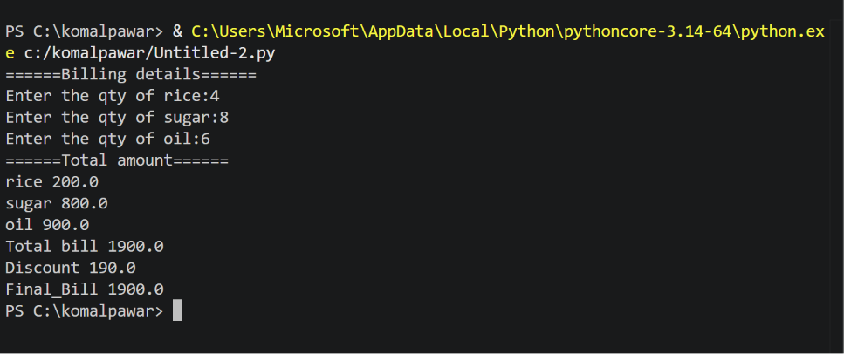

Exercises
Q 1. Develop a program that accept a students marks for three different subjects,calculates their total and average and prints a final scorecards with the average rounded to two decimal places

Code:-
name=input("Enter your name: ")

marks1=float(input("Enter your marks of subject1: "))
marks2=float(input("Enter your marks of subject2: "))
marks3=float(input("Enter your marks of subject3: "))

total = marks1+marks2+marks3
average=total / 3

print("======== Display score card ==========")
print("subject1",marks1)
print("subject2",marks2)
print("subject3",marks3)
print("Total marks",total)
print("Average",round(average))
print("---------------------------")
Output:-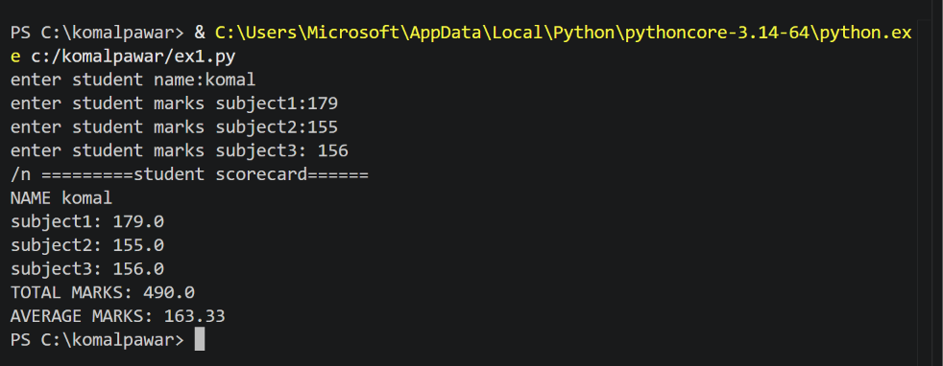-
Q 2. Create a simple profile generator that takes an employee name ,role, and monthly salary and print out a formatted text based employee id card
Code:-
name=(input("Enter employee name :"))
role=(input("Enter employee role :"))
salary=int(input("Enter employee salary :"))

print("==============================")
print(" EMPLOYEE IDENTITY CARD ")
print("==============================")
print("name",name)
print("role",role)
print("salary",format(salary))
print("==============================")
Output:-
